
RAMAIAH
Institute of Technology
USN | 1 | M | S

(Autonomous Institute, Affiliated to VTU)
(Approved by AICTE, New Delhi & Govt. of Karnataka) Accredited by NBA & NAAC with ‘A’ Grade

MAKEUP EXAMINATIONS – FEBRUARY 2019

Course & Branch | : | B.E: Electrical and Electronics Engineering | Semester | : | V
Subject | : | Transmission and Distribution | Max. Marks | : | 100
Subject Code | : | EE53/EE503 | Duration | : | 3 Hrs

Instructions to the Candidates:
- Answer one full question from each unit.

 |  | UNIT- I
1. | a) | Discuss the factors affecting choice of transmission voltage level. | CO1 | (07)
 | b) | Discuss the effect of increase in voltage on the transmission line efficiency. | CO1 | (07)
 | c) | An overhead transmission line has a span of 220m, the conductor weighing 604 kg/km. Calculate the maximum sag if the ultimate tensile strength is 5758 kg. Assume factor of safety = 2. | CO2 | (06)
2. | a) | An overhead line has a span of 150 m between level supports. The conductor has a cross sectional area of 2 cm². The ultimate strength is 5000 kg/cm² and factor of safety is 5. The specific gravity of the material is 8.9 gm/cc. The wind pressure is 1.5 kg/m. Calculate the height of the conductor above the ground level at which it should be supported if a minimum clearance of 7 m is to be left between the ground and the conductor. | CO2 | (10)
 | b) | Name different components of an overhead line. Also explain the purpose for which they are used. | CO2 | (08)
 | c) | Discuss why conductors are not fully stretched between supports. | CO2 | (02)
 |  | UNIT- II
3. | a) | Derive an expression for capacitance of a 3-phase overhead line with unsymmetrical spacing. | CO3 | (12)
 | b) | Calculate the loop inductance per km of a single phase circuit comprising two parallel conductors 1 m apart and 1 cm in diameter. | CO3 | (08)
4. | a) | Show that the presence of earth increases capacitance of transmission lines. | CO3 | (08)
 | b) | Determine the capacitance and charging current per unit length of the line for the horizontal arrangement of conductors of diameter 20mm and spacing 3m. | CO3 | (08)
 | c) | Explain why skin effect is absent in a DC system. | CO3 | (04)
 |  | UNIT- III
5. | a) | Distinguish between short, medium and long transmission lines. | CO4 | (10)
 | b) | Derive an expression for voltage regulation of a short transmission line with vector diagram. | CO4 | (10)
6. | a) | A 220kV, 3-phase transmission line is 40km long. The resistance per phase is 0.15Ω per km and the inductance per phase is 1.5923 mH per km. The line is supplying a 3-phase load of 381 MVA at 0.8 pf lagging. Find: (i) the voltage and power factor at the sending end of the line (ii) the voltage regulation and efficiency of the line. | CO4 | (10)
 | b) | Derive A, B, C, D constants of a medium length transmission line and hence prove that AD – BC = 1. | CO4 | (10)
 |  | UNIT- IV
7. | a) | Each of the three insulators forming a string has a self capacitance of C farads. The shunting capacitance between earth and metal work of each insulator is 0.18 C while it is 0.1 C between metal work and line. Calculate the voltage across each insulator as a percentage of the line conductor voltage to earth and the string efficiency. Now a guard ring is provided, increasing the capacitance to the line of the metal work of the lowest unit to 0.25 C. Calculate the new string efficiency and redistribution of the voltage. | CO5 | (10)
 | b) | What is the use of intersheaths? Explain the principle of intersheath grading of a cable. | CO5 | (10)
8. | a) | Derive an expression for the capacitance of a three core cable and the charging current. | CO5 | (10)
 | b) | A single core cable has a conductor of diameter 2.5 cm and a sheath of inside diameter 6 cm. Calculate the maximum stress. It is desired to reduce the maximum stress by using two intersheaths. Determine their best positions, the maximum stress and the voltages on each system. Voltage is 66 kV, 3 phase. | CO5 | (10)
 |  | UNIT- V
9. | a) | A 2-wire distributor as shown in Fig.9(a), 1200m long is fed at 250V, loads of 80, 70, 100, 90 and 60A are tapped from points B, C, D, E and F whose distances from A are 100, 250, 600, 800 and 1100 metres respectively. If the voltage at G is 210V, find the resistance per metre of distributor.  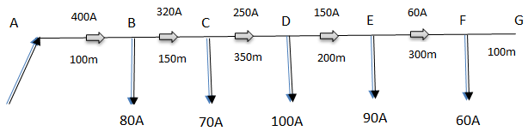  Fig. 9(a) | CO1 | (08)
 | b) | With necessary diagram, explain D.C distributor with concentrated loads fed at one end. | CO1 | (07)
 | c) | Write a note on ring distribution system. | CO1 | (05)
10. | a) | The loading on a distributor is shown in Fig. 10(a). The distributor is a two-core cable for which the resistance and reactance are 0.25 Ω and 0.125 Ω per 1000 metres of cable run respectively. What should be the voltage at the point A to maintain 400V at point D?  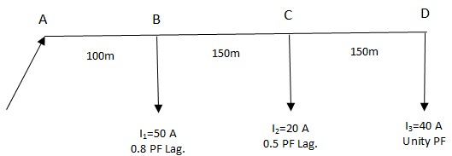  Fig. 10(a) | CO1 | (10)
 | b) | A single phase distributor one km long has resistance and reactance per conductor of 0·1 Ω and 0·15 Ω respectively. At the far end, the voltage V_{B} = 200 V and the current is 100 A at a p.f. of 0·8 lagging. At the mid-point M of the distributor, a current of 100 A is tapped at a p.f. of 0·6 lagging with reference to the voltage V_{M} at the mid-point. Calculate :  (i) voltage at mid-point  (ii) sending end voltage V_{A}  (iii) phase angle between V_{A} and V_{B.} | CO1 | (10)

****************

